**22AIE303 – PROJECT PHASE 2**

**RELATIONAL MAPPING**

**GROUP 5**

|  |  |
| --- | --- |
| **Name** | **Roll number** |
| Aparna Balaji | AM.EN.U4AIE22005 |
| Anuvind M P | AM.EN.U4AIE22010 |
| R S Harish Kumar | AM.EN.U4AIE22042 |
| Siddharth Menon | AM.EN.U4AIE22048 |

**ER-DIAGRAM :**

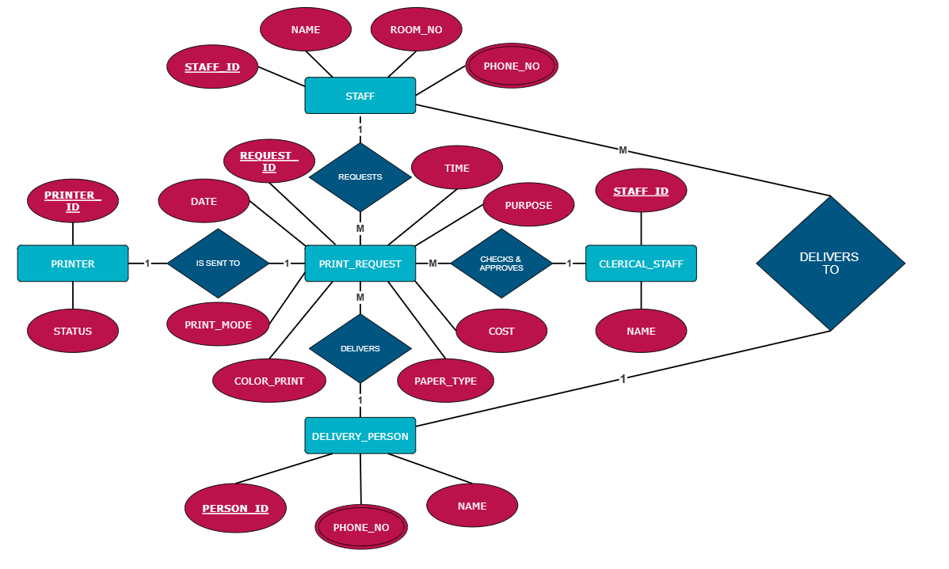

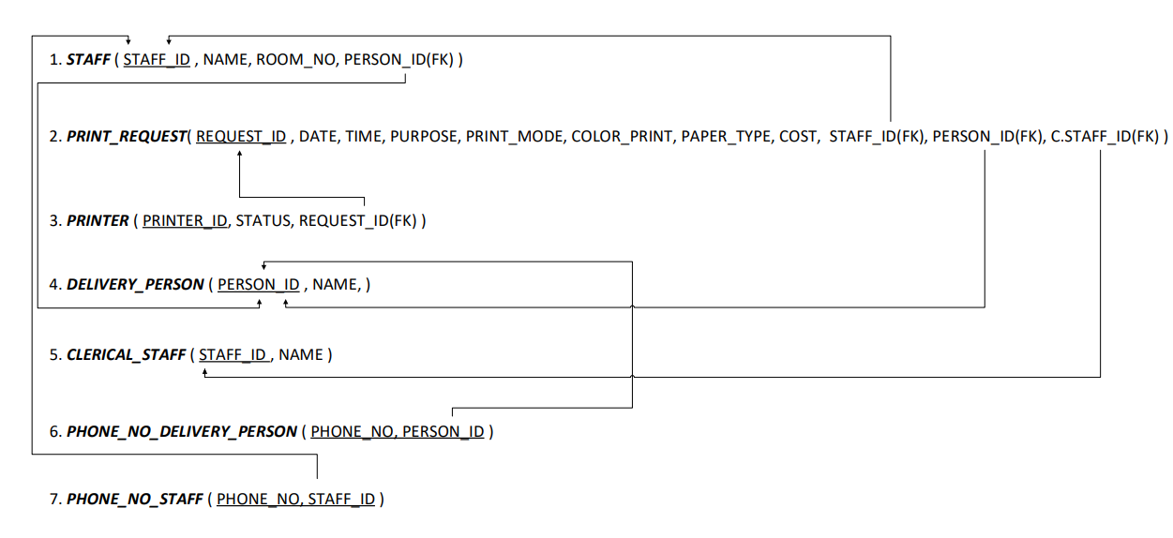**RELATIONAL MAPPING :**

**CREATE TABLE QUERIES :**

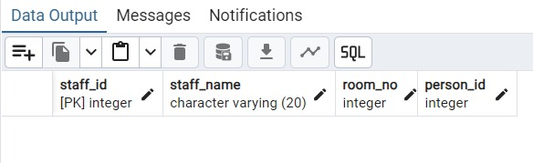

CREATE TABLE staff(

staff_id int PRIMARY KEY,

staff_name varchar(20),

room_no int,

person_id int REFERENCES delivery_person(person_id)

);

CREATE TABLE print_request(

request_id int PRIMARY KEY,

req_date date,

req_time time,

purpose varchar(50),

print_mode varchar(20),

color_print boolean,

paper_type varchar(10),

cost numeric(10,2),

staff_id int REFERENCES staff(staff_id),

person_id int REFERENCES delivery_person(person_id),

cstaff_id int REFERENCES clerical_staff(cstaff_id)

);

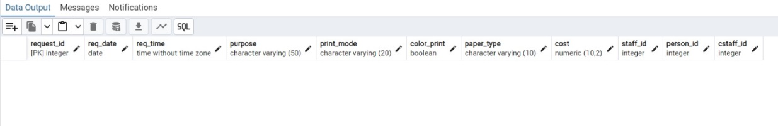

CREATE TABLE printer(

printer_id int PRIMARY KEY,

status varchar(20),

request_id int REFERENCES print_request(request_id)

);

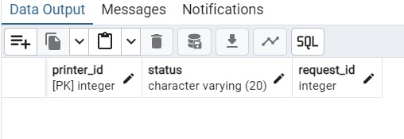

CREATE TABLE delivery_person(

person_id int PRIMARY KEY,

person_name varchar(20)

);

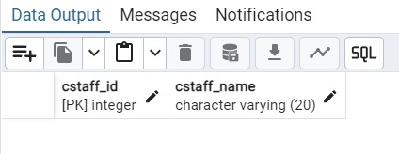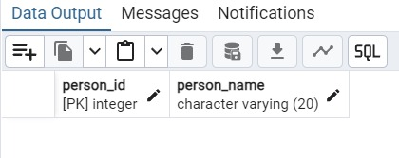

CREATE TABLE clerical_staff(

cstaff_id int PRIMARY KEY,

cstaff_name varchar(20)

);

CREATE TABLE person_number(

person_id int REFERENCES delivery_person(person_id),

person_no int,

PRIMARY KEY(person_id, person_no)

);

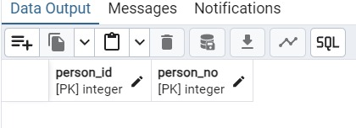

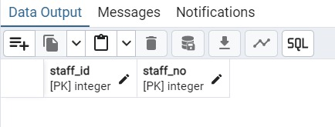

CREATE TABLE staff_number(

staff_id int REFERENCES staff(staff_id),

staff_no int,

PRIMARY KEY(staff_id, staff_no)

);

**RELATIONSHIPS AND CARDINALITIES :**

1. **Relationships:**
   * **Requests**: Links Staff with Print_Request, indicating which staff member made a request.
   * **Is_Sent_To:** Links Print_Request to Printer, indicating which printer is assigned to process the request.
   * **Delivers:** Links Print_Request to Delivery_Person, indicating the delivery assignment for each request.
   * **Checks & Approves:** Links Clerical_Staff to Print_Request, indicating the approval process for requests.
   * **Delivers_To:** Links Delivery_Person to Staff to show delivery completion.
2. **Cardinalities:**
   * **One** Staff can make **many** Print_Requests.
   * **One** Print_Request is sent to a **single** Printer.
   * **One** Delivery_Person can deliver **many** print jobs, and **one** print request is delivered by a **single** person.
   * **One** Clerical_Staff can approve **many** requests**.**

**RELATIONAL SCHEMA DESCRIPTION :**

1. **Staff Table**:
   * **Schema**: STAFF(STAFF_ID(PK), NAME, ROOM_NO)
   * Description: Contains details of employees requesting print jobs. The STAFF_ID is the primary key and links to Print_Request and Clerical_Staff.
2. **Print_Request Table**:
   * **Schema**: PRINT_REQUEST(REQUEST_ID(PK), DATE, TIME, PURPOSE, PRINT_MODE, COLOR_PRINT, PAPER_TYPE, COST, STAFF_ID(FK), PRINTER_ID(FK), PERSON_ID(FK))
   * Description: Stores information about print requests. It has foreign keys linking to the Staff, Printer, and Delivery_Person tables.
3. **Printer Table**:
   * **Schema**: PRINTER(PRINTER_ID(PK), STATUS)
   * Description: Contains details about printers. It has a foreign key REQUEST_ID linking to the Print_Request table.
4. **Delivery_Person Table**:
   * **Schema**: DELIVERY_PERSON(PERSON_ID(PK), NAME)
   * Description: Represents delivery personnel assigned to print jobs.
5. **Clerical_Staff Table**:
   * **Schema**: CLERICAL_STAFF(STAFF_ID(PK), NAME)
   * Description: Stores information about staff members responsible for approving print requests. It shares STAFF_ID as a primary key.
6. **Phone_No_Delivery_Person Table**:
   * **Schema**: PHONE_NO_DELIVERY_PERSON(PHONE_NO, PERSON_ID(FK))
   * Description: Manages contact numbers for delivery personnel.
7. **Phone_No_Staff Table**:
   * **Schema**: PHONE_NO_STAFF(PHONE_NO, STAFF_ID(FK))
   * Description: Stores contact numbers for staff members.